**Check My Chair Project**

**Objective:**

To develop an IoT-based system that detects whether a chair is occupied or unoccupied using a Force Sensitive Resistor (FSR) and transmits this status along with GPS location to an online database (or optionally to a mobile app). This helps in locating free chairs in public or institutional settings.

**Key IoT Components Used:**

1. ESP32 Dev Module

* Microcontroller with WiFi & Bluetooth support
* Acts as the brain of the system, reads FSR sensor and GPS data, and sends them over WiFi.

1. FSR (Force Sensitive Resistor)

* Used to detect pressure/weight (presence of a person).
* Changes its resistance based on the applied force.

1. NEO-6M GPS Module

* Provides real-time GPS coordinates of the chair.
* Communicates with ESP32 via serial communication.

1. Power Source

* A USB power bank (or direct USB from laptop) powers the ESP32.

**Working Principle:**

1. Chair Monitoring Logic:

* When someone sits on the chair, the FSR detects pressure.
* The ESP32 reads the analog value from the FSR and compares it with a threshold to determine if the chair is occupied.

1. GPS Tracking:

* NEO-6M GPS module provides real-time latitude and longitude data.
* This helps in uniquely identifying and locating each chair.

1. Data Handling:

* Based on FSR and GPS input, ESP32 prepares a data packet (e.g., chair ID, status, coordinates).
* This data can optionally be sent over WiFi to cloud platforms like Firebase, Ubidots, or displayed via Serial Monitor for local testing.

**Circuit Diagram:**

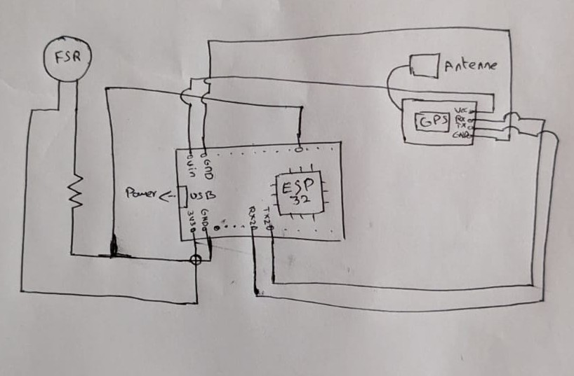

**Conclusion and Future Scope:**

This project demonstrates a successful proof-of-concept for a smart seating solution using IoT technology. It effectively combines sensor data acquisition, data processing, and communication protocols into a cohesive and practical system.

**Potential Future Enhancements:**

* Cloud Integration and Mobile App: Fully develop the backend on a cloud platform like Firebase and create a user-friendly mobile application that visualizes the data on a map.
* Power Optimization: Implement the ESP32's deep-sleep modes to significantly reduce power consumption, allowing for long-term battery-powered operation.
* Miniaturization: Design a custom PCB to create a more compact and aesthetically pleasing enclosure that can be unobtrusively integrated into chair designs.
* Reservation System: Add functionality to the app allowing users to reserve a vacant chair for a short period.

